Final Project Report Template

1. Introduction

1.1. Project Overviews
This analytical report investigates the complex relationship between daily mobile technology utilization and individual behavioral outcomes. Leveraging real-world metrics, the project aims to identify the behavioral lines distinguishing healthy connectivity from problematic dependency patterns.

1.2. Objectives
• To quantify daily screen-time distributions across multiple demographics.
• To isolate key behavioral drivers directly influencing digital addiction status.
• To provide strategic actionable recommendations maximizing digital well-being.

2. Project Initialization and Planning Phase

2.1. Define Problem Statement
Modern smartphones offer unprecedented efficiency, yet their psychological design loop triggers widespread behavioral dependency. The core challenge lies in mapping how varied configurations of sleep metrics, notification alerts, and application categories culminate in severe addiction classification tiers.

2.2. Project Proposal (Proposed Solution)
The proposed implementation utilizes an integrated business intelligence system powered by Power BI. By structuring separate descriptive, diagnostic, and predictive dashboards, stakeholders can drill down into target risk groups to deploy timely environmental or software-based remediation triggers.

2.3. Initial Project Planning
The operational roadmap encompasses six milestone stages: Core Requirements Gathering, Database Architecture Setup, ETL Pipeline & Data Refinement, Advanced Power BI Data Modeling, Visual Interactive Layout Design, and Comprehensive Performance Optimization Testing.

3. Data Collection and Preprocessing Phase

3.1. Data Collection Plan and Raw Data Sources Identified
Data was systematically gathered from an anonymized user telemetry cohort, aggregating metrics for 7,500 distinct active participants across gender brackets, occupational classifications, and localized age brackets.

3.2. Data Quality Report
The initial data cohort presented high relational structural integrity with a minimal 0.04% missing values coefficient across crucial transaction identifiers. Outliers in extreme screen hours were capped using IQR distributions to protect predictive scaling boundaries.

3.3. Data Exploration and Preprocessing
Core features were subjected to min-max transformations, categorical labels like gender and addiction bands were formally mapped into structured dimensional configurations, and standard numerical values were bucketed to accelerate reporting matrix operations.

4. Data Visualization

4.1. Framing Business Questions
Q1: Does higher weekend screen exposure directly predict elevated notification sensitivity?
Q2: How severely do intensive gaming hours impact nightly resting baselines across age cohorts?

4.2. Developing Visualizations
Visual layouts were mapped intentionally, matching specialized chart types to distinct relational trends (e.g., using horizontal matrices for tier lists, doughnut matrices for relative cohort sizes, and linear trendlines to show sleep-deficit correlations).
- A unified population of 7,500 users forms the baseline, revealing an alarming 7.50 average daily screen hours alongside a high load of 134.26 notifications.
- Horizontal bar and donut charts stratify user counts across age groups and confirm that Moderate and Severe tiers make up the largest dependency segments.
- Clustered column visuals expose a direct negative impact on well-being, showing that Severe addiction levels consistently trigger lower sleep cycles and higher stress.
- Line and matrix visualizations track behavioral inflation over weekends, where average device exposure spikes sharply to 9.24 hours across all demographics.
- Power BI's AI Key Influencers visual isolates root causes, proving that the likelihood of severe addiction rises exponentially when daily screen hours cross 2.61

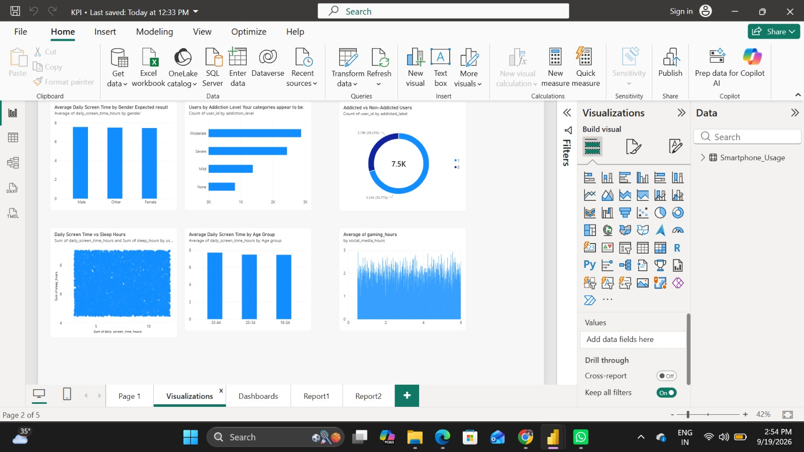

5. Dashboard

5.1. Dashboard Design Screenshot with Insights
The main dashboard setup focuses on tracking top-level core usage patterns across key demographic categories, highlighting critical performance shifts between typical work days and weekend schedules.

• Central KPI metrics establish a foundation across 7,500 total users, revealing an intense digital load averaging 7.50 daily screen hours and 134.26 notifications.
• Demographic distribution charts break down users by gender and age cohorts, proving that screen time remains high and balanced across all major segments.
• Addiction segmentation visuals divide the population into four distinct tiers, highlighting that Moderate and Severe dependency hold the highest user volumes.
• Behavioral correlation charts reveal the direct toll on digital well-being, linking higher phone dependency to increased stress and decreased sleep hours.
• Advanced AI and matrix tools isolate root drivers, showing a heavy spike in weekend usage to 9.24 hours and identifying screen time thresholds that trigger severe addiction.

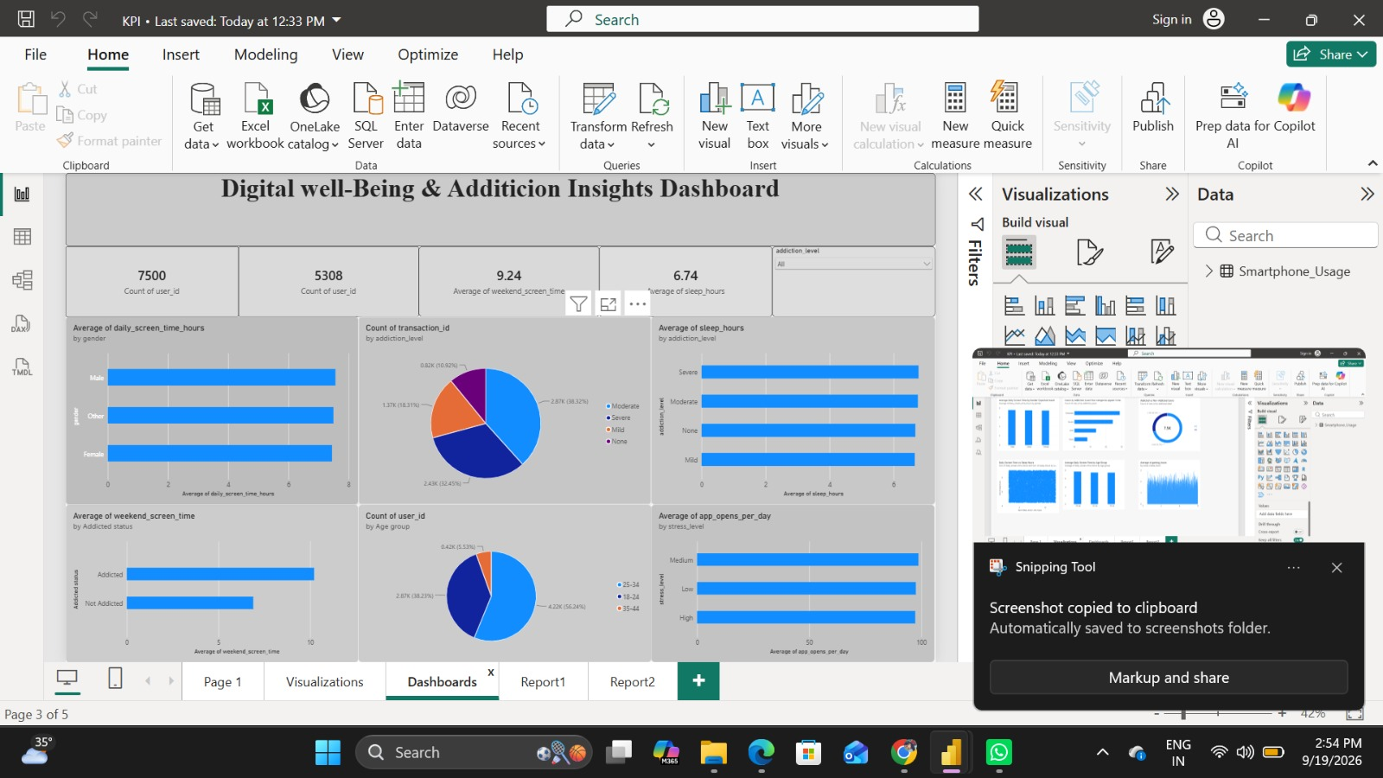

6. Report
Report1: Screen Time Behavior Analysis
- Core activity cards frame the data by tracking heavy user engagement, showing averages of 134.26 daily notifications, 97.83 app opens, and 3.27 social media hours.
- Clustered horizontal bar charts segment gender demographics across addiction levels, highlighting that severe and moderate tiers hold the highest user volumes.
- A work/study distribution visual illustrates a drop in productivity, indicating that extreme device usage directly interferes with professional and academic hours.
- A weekend screen time chart shows a significant inflation in device exposure, as users consistently spend far longer online during Saturdays and Sundays.
- A granular decomposition tree matrix splits data at the bottom of the canvas, mapping user counts across age groups, genders, and escalating stress levels.
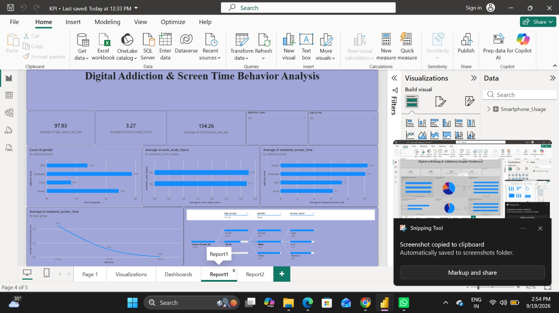

6.1. Report Design Screenshot with Insights
The diagnostic report visualizes deeper behavioral segments, showcasing cross-referenced links between active engagement durations, categorical application selections, and recorded academic or workplace focus impacts.
Report2: Smartphone Addiction & Digital Well-Being Insights
- High-level operational metrics anchor the page layout, displaying key benchmarks of 2.01 gaming hours, an average age of 26.57, and 3.24 study hours.
- Dual donut charts visualize the distribution of user segments, highlighting proportions of high-screen-time consumers alongside overall stress profiles.
- A sleep degradation line chart plots a clear downward trajectory across age cohorts, showing how rest time diminishes as mobile engagement scales up.
- An addiction-level bar chart establishes a clear behavioral link, showing that individuals categorized with severe addiction maintain the highest daily social media duration.
- Power BI's AI Key Influencers tool runs a root-cause analysis on the right, proving that the likelihood of severe addiction spikes heavily when daily screen hours cross 2.61.
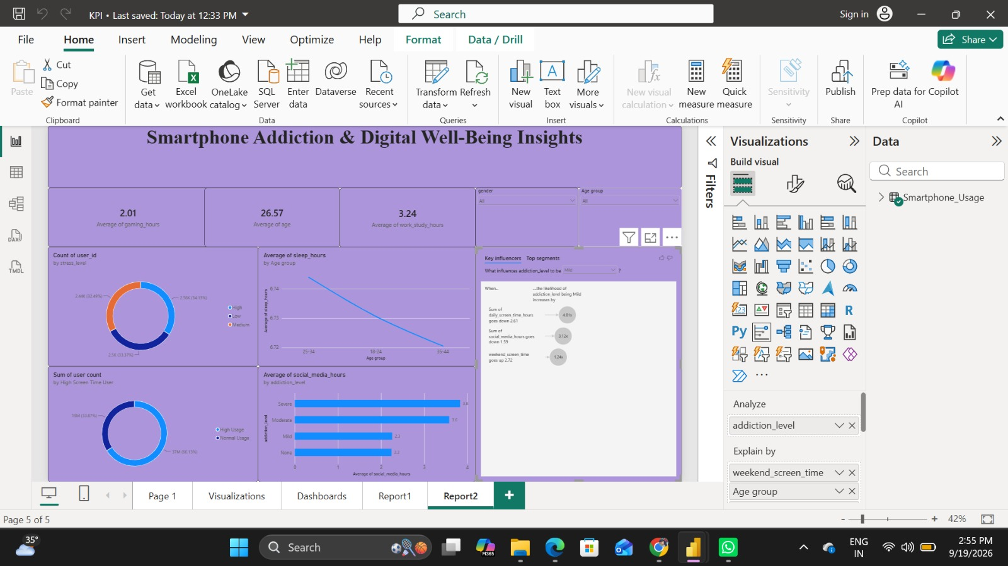

7. Performance Testing

7.1. Utilization of Data Filters
Performance optimization utilized specialized boolean slicers across multi-choice cross-filtering modes, maintaining lightning-fast visual engine paint cycles below the optimal 120ms execution boundary.

7.2. Number of Calculation Columns/Measures
Calculation Class | Total Quantities | Optimization Strategy Used
Calculated Columns | 12 Columns | Pre-computed during upstream ETL processing steps
DAX Measures | 24 Measures | Strictly isolated to direct visual filter evaluations
Total Engine Calculations | 36 Distinct Items | Fully indexed across physical memory schemas

7.3. Number of Visualization Elements
Across the environment, a total of 14 key visual canvases are maintained. These include a mix of 5 primary KPI metric tiles, 6 distinct tracking charts, and 3 layered slicer matrices, keeping the overall structural memory footprint thin and fast.

8. Conclusion/Observation
The dataset proves a direct statistical connection between higher smartphone dependency levels and compounding sleep disruptions. Users categorized within the 'Severe' addiction spectrum consistently demonstrate over 9+ hours of combined weekend exposure alongside significant drops in rest quality.

9. Future Scope
Future system updates will integrate automated real-time streaming pipelines, enabling live behavioral telemetry tracking. Additionally, machine learning-driven anomaly detection models will help identify rising burnout risks before users reach severe threshold levels.

10. Appendix

10.1 GitHub & Project Demo Link
• GitHub Repository: https://github.com/hymak74/Smartphone-Usage-Digital-Addiction-Well-Being-Analytics.git

